**Create a new container**

docker run -i -t --name container1 ubuntu:14.04 /bin/bash

root@9d9d6e9dc6dc:/# apt-get update

root@9d9d6e9dc6dc:/# apt install apache2 git

root@9d9d6e9dc6dc:/# exit

docker commit container1 anilbidari/ubuntu:1.0



docker images

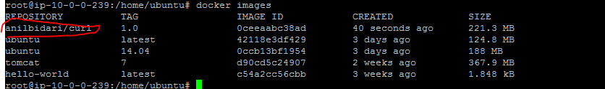

docker run -i -t anilbidari/ubuntu:1.0 /bin/bash

**try installing curl again : notice the difference**

root@87656d52abac:/# apt-get install git

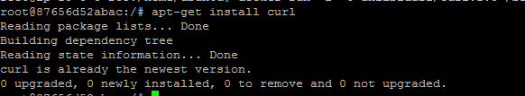

root@87656d52abac:/# which git

**exit the container**

root@87656d52abac:/# exit